Lecture 15

Lun Scanning-DiskScanning-Logical-Extended Partition

fdisk (further)

* Requirement case
* 
* A 5Gb disk space
* At least 7Gb space would be sufficient for this task
* 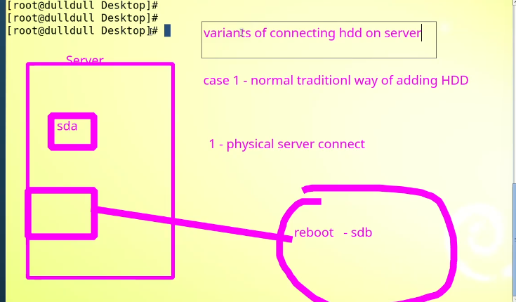
* 2nd way
* 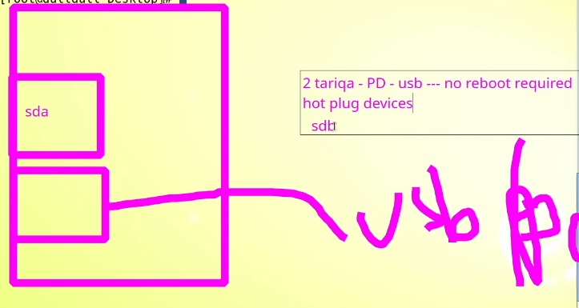
* 3rd way
* 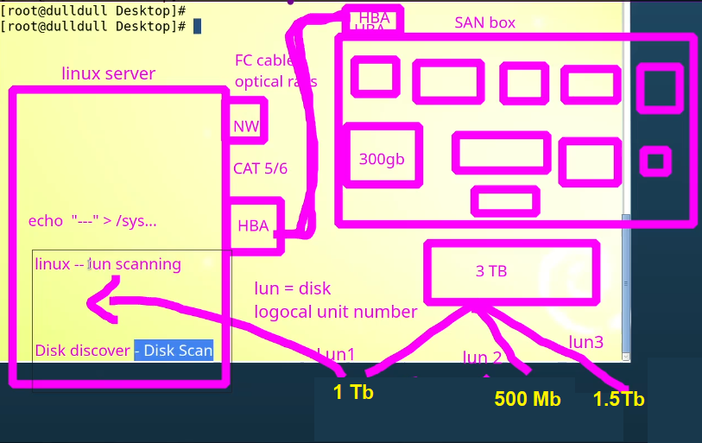
* HBA – host bus adapter
* LUN (Logical Unit Number)– Scanning 🡪
* The 3 LUNs from SAN are called “targets”.
* The Linux Server is called “initiator”.
* The HHD controller is called “SCSI Controller”
* SAN
* 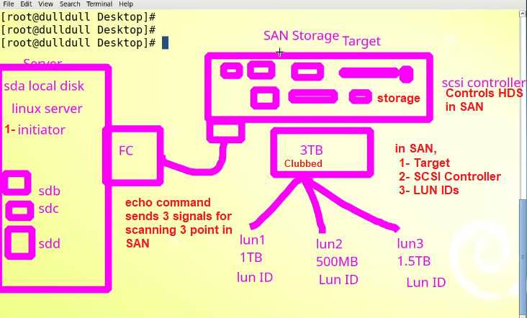
* **$ echo “- - - “> /sys/class/scsci_host0/scan**
* **$ echo “- - - “> /sys/class/scsci_host1/scan**
* **$ echo “- - - “> /sys/class/scsci_host2/scan**
* **We rum this command 3 times (not a thumb rule)**
* “- - - “ 3 dashes, 🡪 1- Target Scanning, 2- SCSCI controllers scanning, 3- LUN ID scanning
* 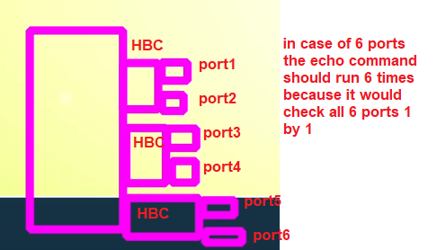
* In case of VMware, or VirtualBox
* “echo” command is run to pretend as scanning just like SAN
* **How many partitions can be created in a Hard Drive?**
* In Linux server Only 4 (primary) partitions can be created in a HDD.( from any source , from SAN VMDK etc.)
* **Even if space is available , we can only make 4 partitions**
* 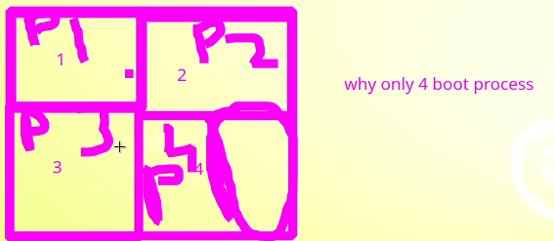
* To create more than 4 partitions, an “extended” partition must be made.
* P4 + extended partition
* **The additional partitions in extended partition are called “logical” partitions. Extended partitions are also called “as primary partitions”.**
* **“63 logical partitions can be made.”**
* **Primary partitions = 4**
* **Extended = 1**
* **Logical = 63**
* **The extended partition is only for “name’s sake”.**
* **Fact: -**
* If you create 2nd partition as extended partition, then sdb3 and sd4 names would be skipped and all logical partitions would be created from sdb5
* 